Topic as per syllabus | As per Text Book
Multithreaded Programming: Overview, Multi-core Programming,  Multithreading Models, Implicit Threading, Threading Issues. | Chapter 4 Threads  4.1 Overview  4.2 Multicore Programming  4.3 Multithreading Models  4.5 Implicit Threading  4.6 Threading Issues
Process Scheduling: Basic concepts, Scheduling Criteria, Scheduling  Algorithms. Thread Scheduling, Multiple-Processor Scheduling, Real-Time  CPU Scheduling | Chapter 6 CPU Scheduling  6.1 Basic Concepts 261  6.2 Scheduling Criteria 265  6.3 Scheduling Algorithms 266  6.4 Thread Scheduling 277  6.5 Multiple-Processor Scheduling 278  6.6 Real-Time CPU Scheduling 283

Section | Topic Title | Purpose | Role | 🔥 Key Highlights
6.6 | Real-Time CPU Scheduling | What is real-time system | Foundation | Soft vs Hard real-time, deadlines are critical
6.6.1 | Minimizing Latency | How fast system reacts | Performance | Event latency = Interrupt + Dispatch latency
6.6.2 | Priority-Based Scheduling | Use priority | Basic rule | High-priority tasks execute first, preemption used
6.6.3 | Rate-Monotonic Scheduling (RMS) | Fixed priority assignment | Algorithm | Shorter period → higher priority, static
6.6.4 | Earliest Deadline First (EDF) | Dynamic priority assignment | Advanced algorithm | Earlier deadline → higher priority, flexible
6.6.5 | Proportional Share Scheduling | Fair CPU allocation | Fairness approach | CPU divided based on shares (%), lottery/stride
6.6.6 | POSIX Real-Time Scheduling | Implementation in OS | Practical layer | Uses SCHED_FIFO, SCHED_RR, APIs for control

6.6 Real-Time CPU Scheduling
CPU scheduling for real-time operating systems involves special issues. In general, we can distinguish between soft real-time systems and hard real-time systems.
Soft real-time systems provide no guarantee as to when a critical real-time process will be scheduled. They guarantee only that the process will be given preference over noncritical processes. Hard real-time systems have stricter requirements. A task must be serviced by its deadline; service after the deadline has expired is the same as no service at all. In this section, we explore several issues related to process scheduling in both soft and hard real-time operating systems.

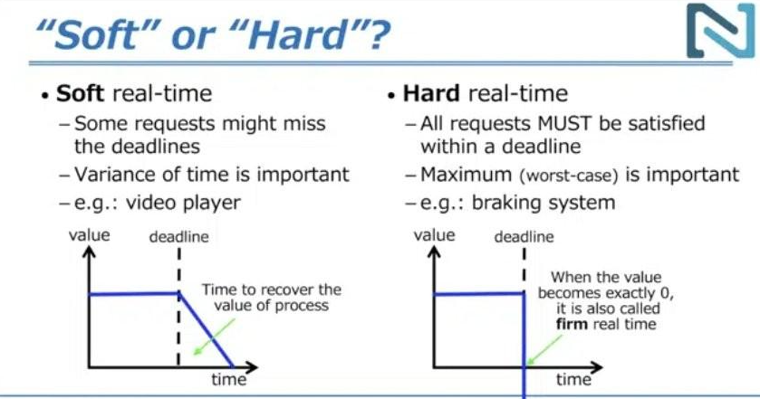
6.6.1 Minimizing Latency
• Events may arise either in software —as when a timer expires—or
• in hardware—as when a remote-controlled vehicle detects that it is approaching an obstruction.
• When an event occurs, the system must respond to and service it as quickly as possible.
• event latency as the amount of time that elapses from when an event occurs to when it is serviced
• Ex. 1. Vehicle brake maynot accept delay
• Ex 2. Radar may accepts delay in seconds
When an event occurs, the system must respond to and service it as quickly as possible. We refer to event latency as the amount of time that elapses from when an event occurs to when it is serviced (Figure 6.12).
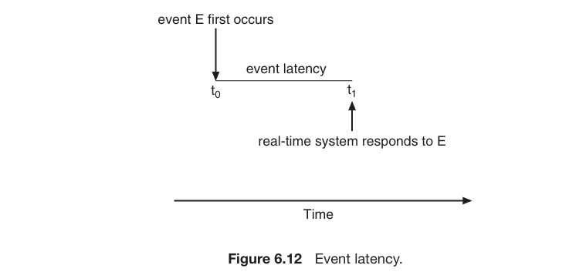
Two types of latencies affect the performance of real-time systems:
1. Interrupt latency
2. Dispatch latency
Interrupt latency refers to the period of time from the arrival of an interrupt at the CPU to the start of the routine that services the interrupt. When an interrupt occurs, the operating system must first complete the instruction it is executing and determine the type of interrupt that occurred. It must then save the state of the current process before servicing the interrupt using the specific interrupt service routine (ISR). The total time required to perform these tasks is the interrupt latency.
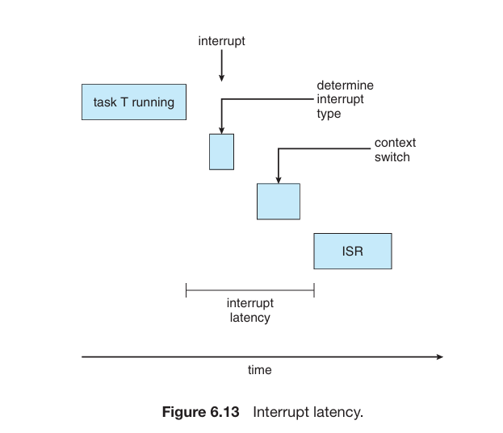
Dispatch latency is the amount of time required by the scheduling dispatcher to stop one process and start another. The most effective technique for keeping dispatch latency low is to provide preemptive kernels.
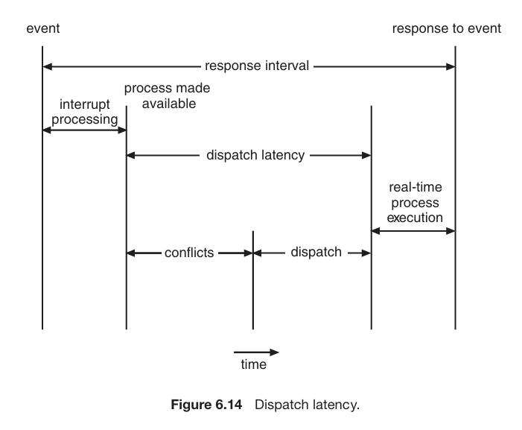
The conflict phase in dispatch latency has 2 parts:
- Preemption of any process running in the kernel.
- Release by low-priority processes of resources needed by a high-priority process
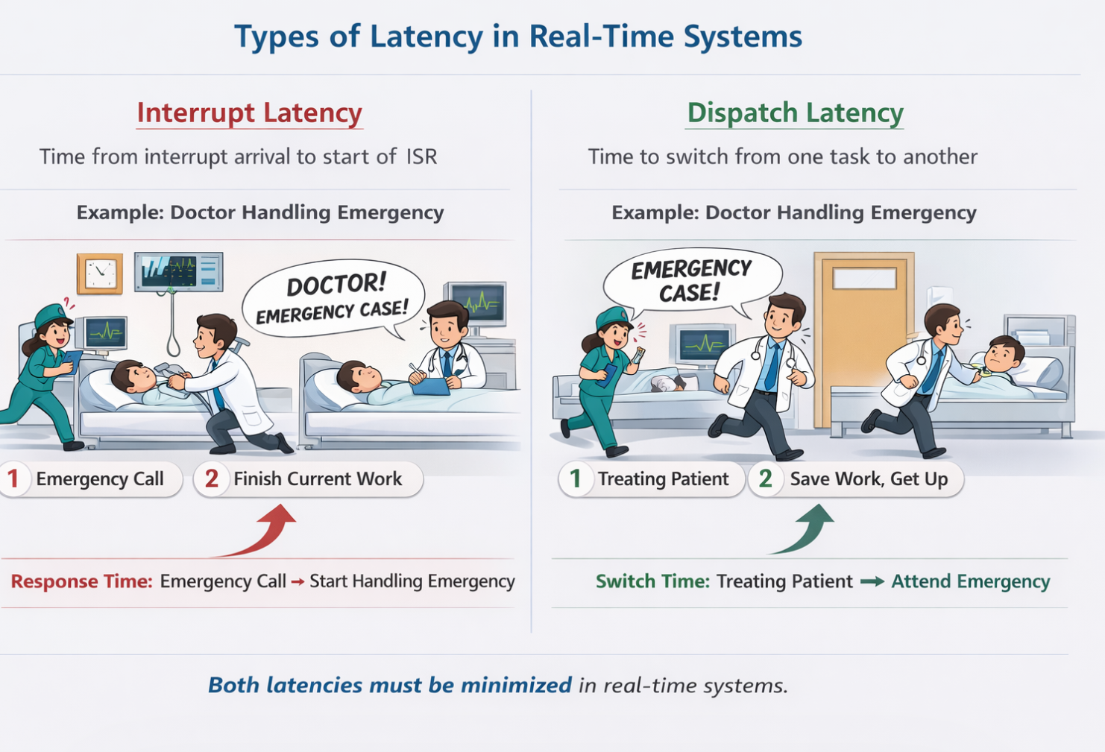
Interrupt latency is the time taken to detect and respond to an interrupt, dispatch latency is the time taken to start executing the handler, and the ISR (Interrupt Service Routine) is the function that finally executes to handle the interrupt event.
Step | Real World
Doctor notices patient | Interrupt latency
Doctor prepares tools | Dispatch latency
Doctor treats patient | ISR

Point | Interrupt Latency | Dispatch Latency
1. Meaning | Time to start handling an interrupt | Time to switch CPU to new task
2. When it happens | When event/interrupt arrives | After interrupt, when task is ready
3. What it includes | Detect interrupt, finish current instruction, save state | Stop current task, context switch, start new task
4. Example (Doctor) | Time taken for doctor to know about emergency | Time taken for doctor to leave current patient and treat emergency
5. Role | Reaction delay | Execution switch delay

6.6.2 Priority-Based Scheduling
Real time systems are required to immediately respond to a real time process. As a result it needs to support a priority based scheduling algorithm with preemption. Since it is priority based each process must be assigned a priority and since it is preemptive, a process currently running on the CPU will be preempted if a higher-priority process becomes available to run.
We have already discussed preemptive priority based scheduling in previous section . Most OS give the highest priority to real time processes. A preemptive priority based scheduler only provides soft real time functionality. We need other considerations for hard real time systems. In the coming parts we will discuss considerations for hard real time systems.
Symbol | Meaning | Simple Meaning
t | Processing time | Time needed to finish the task
d | Deadline | Time before which task must finish
p | Period | After how much time task repeats

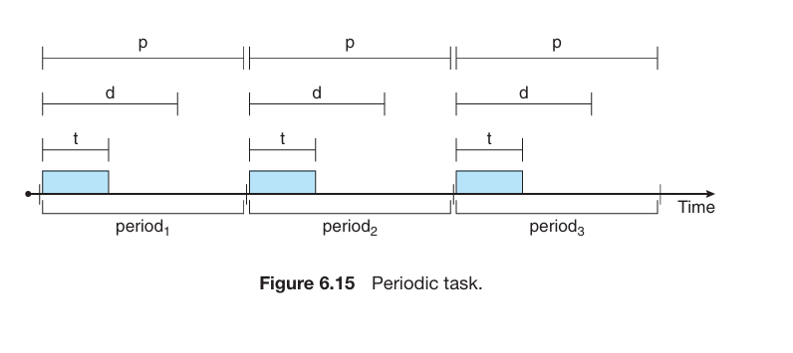
Concept | Symbol | Meaning | Example (Heart Monitor) | Key Point
Execution Time | t | Time required to complete task | 2 sec | Task must finish within this time
Deadline | d | Time limit to complete task | 8 sec | Must finish before this
Period | p | Time interval between repetitions | 10 sec | Task repeats every 10 sec
Condition | — | Relationship between values | 0 ≤ t ≤ d ≤ p | Must always satisfy
Rate | 1/p | Frequency of task | 1/10 | Smaller p → higher rate

Both Rate-Monotonic Scheduling and Earliest Deadline First are used in hard real-time systems

Parameter Used | Scheduling Algorithm | Meaning
Deadline (d) | EDF | Earlier deadline → higher priority
Period (p) | RMS | Smaller period → higher priority

6.6.3 Rate-Monotonic Scheduling
The rate-monotonic scheduling algorithm schedules periodic tasks using a static priority policy with preemption. If a lower-priority process is running and a higher-priority process becomes available to run, it will preempt the lower-priority process.
Upon entering the system, each periodic task is assigned a priority inversely based on its period. The shorter the period, the higher the priority; the longer the period, the lower the priority.
Let us now consider 2 processes, P1 and P2. The time period of each is 50 and 100 respectively (p1 = 50 & p2 = 100). We also consider the processing time to be 20 and 35 respectively (t1 = 20 & t2 = 35). The deadline for each process requires that it complete its CPU burst by the start of its next period.
Suppose we assign P2 a higher priority than P1. As we can see, P2 starts execution first and completes at time 35. At this point, P1 starts; it completes its CPU burst at time 55. However, the first deadline for P1 was at time 50, so the scheduler has caused P1 to miss its deadline.
But if we were to use Rate Monotonic Scheduling, P1 has a higher priority than P2 because the period of P1 is shorter than that of P2. P1 starts first and completes its CPU burst at time 20, thereby meeting its first deadline. P2 starts running at this point and runs until time 50. At this time, it is preempted by P1, although it still has 5 milliseconds remaining in its CPU burst. P1 completes its CPU burst at time 70, at which point the scheduler resumes P2. P2 completes its CPU burst at time 75, also meeting its first deadline. The system is idle until time 100, when P1 is scheduled again.
Rate-monotonic scheduling is considered optimal in that if a set of processes cannot be scheduled by this algorithm, it cannot be scheduled by any other algorithm that assigns static priorities.
Despite being optimal, then, rate-monotonic scheduling has a limitation: CPU utilisation is bounded, and it is not always possible fully to maximise CPU resources. The worst-case CPU utilisation for scheduling N processes is 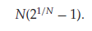
Example 1:
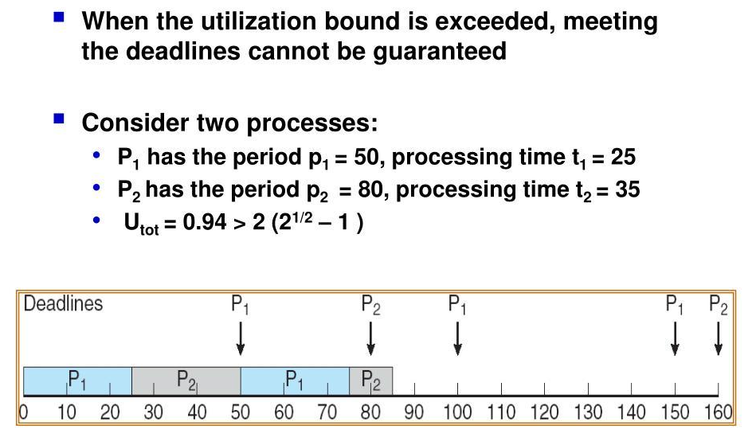
Example 2:
Process | Execution Time (C) | Period (T)
P1 | 30 | 50
P2 | 40 | 100

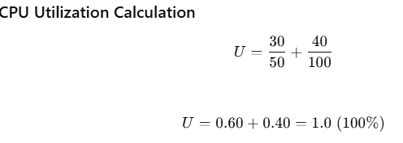
Metric | Value
Calculated Utilization | 100%
RMS Limit (n=2) | 82.8%
Conclusion | ❌ Not schedulable

Example 3:
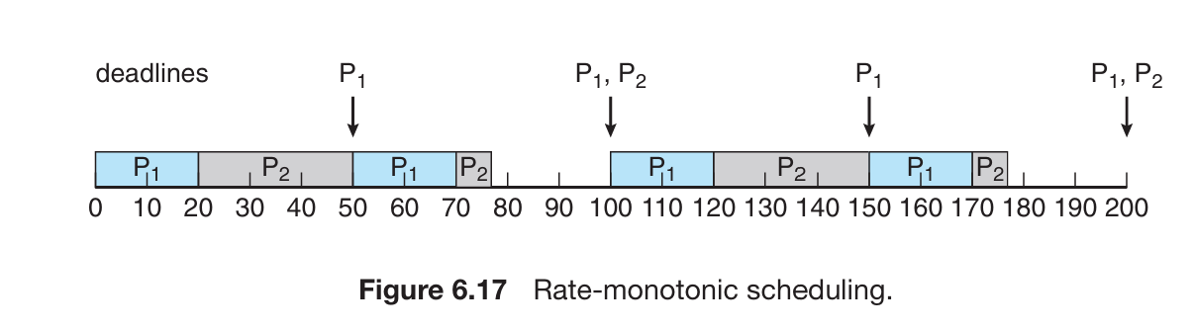
Given this values
Process | Period (p) | Execution Time (t) | Deadline (d)
P1 | 50 | 20 | 50
P2 | 100 | 35 | 100

CPU Utilization Check Conclusion: Scheduling is possible (CPU < 82.8%)
Process | Formula | Utilization
P1 | 20/50 | 0.40
P2 | 35/100 | 0.35
Total | — | 0.75 (75%)
Case 1: Wrong Priority (P2 > P1)
Step | Time Interval | Running Process | Remarks
1 | 0 – 35 | P2 | P2 completes
2 | 35 – 55 | P1 | P1 completes late

Process | Deadline | Completion Time | Result
P1 | 50 | 55 | ❌ Missed
P2 | 100 | 35 | ✅ Met

Case 2: RMS Scheduling (Correct Priority)
Process | Period | Priority
P1 | 50 | 🔥 High
P2 | 100 | Low

Step | Time Interval | Running Process | Deadline | Remarks
1 | 0 – 20 | P1 | 50 | Completes before deadline ✔
2 | 20 – 50 | P2 | 100 | Partial execution
3 | 50 – 70 | P1 | 100 | 🔥 Preempts P2, completes ✔
4 | 70 – 75 | P2 | 100 | Completes remaining ✔

Step | Time Interval | Ready Queue | Deadline | Remarks
1 | 0 – 20 | [P1, P2] | P1→50, P2→100 | 🔥 P1 runs (higher priority), completes ✔
2 | 20 – 50 | [P2] | P2→100 | P2 executes partially
3 | 50 – 70 | [P1, P2] | P1→100, P2→100 | 🔥 P1 arrives & preempts P2, completes ✔
4 | 70 – 75 | [P2] | P2→100 | P2 completes ✔

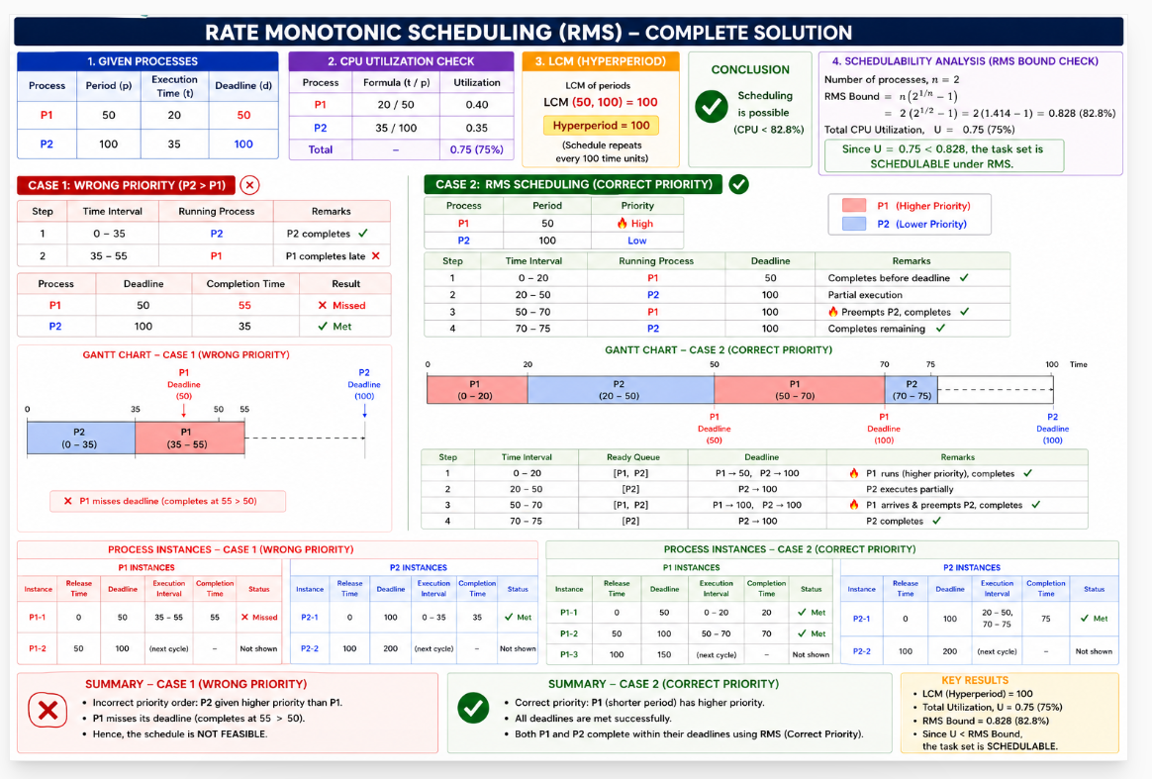

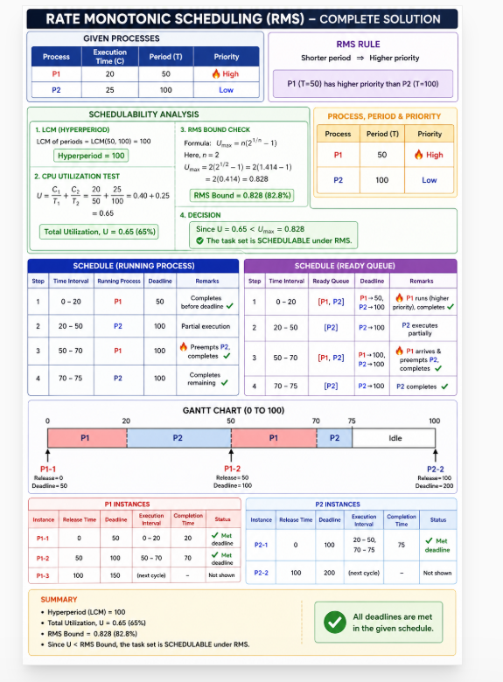

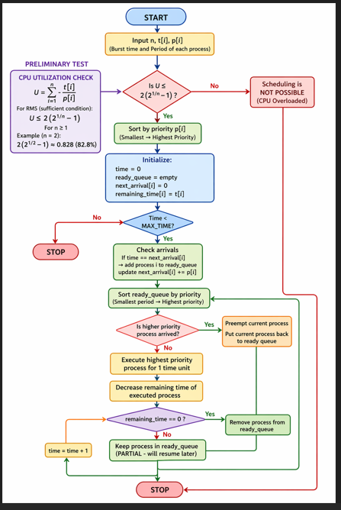

6.6.4 Earliest-Deadline-First Scheduling
Earliest-deadline-first (EDF) scheduling dynamically assigns priorities according to deadline. The earlier the deadline, the higher the priority and the later the deadline, the lower the priority. Under the EDF policy, when a process becomes runnable, it must announce its deadline requirements to the system. Priorities may have to be adjusted to reflect the deadline of the newly runnable process.
Let us again consider the processes that we have seen above (p1 = 50, p2 = 80, t1 = 20, t2 = 35). Process P1 has the earliest deadline, so its initial priority is higher than that of process P2. Process P2 begins running at the end of the CPU burst for P1. However, whereas rate monotonic scheduling allows P1 to preempt P2 at the beginning of its next period at time 50, EDF scheduling allows process P2 to continue running. P2 now has a higher priority than P1 because its next deadline (at time 80) is earlier than that of P1 (at time 100). Thus, both P1 and P2 met their first deadlines. Process P1 again begins running at time 60 and completes its second CPU burst at time 85, also meeting its second deadline at time 100. P2 begins running at this point, only to be preempted by P1 at the start of its next period at time 100. P2 is preempted because P1 has an earlier deadline (time 150) than P2 (time 160). At time 125, P1 completes its CPU burst and P2 resumes execution, finishing at time 145 and meeting its deadline as well. The system is idle until time 150, when P1 is scheduled to run once again.
Unlike the rate-monotonic algorithm, EDF scheduling does not require that processes be periodic, nor must a process require a constant amount of CPU time per burst. The only requirement is that a process announce its deadline to the scheduler when it becomes runnable.
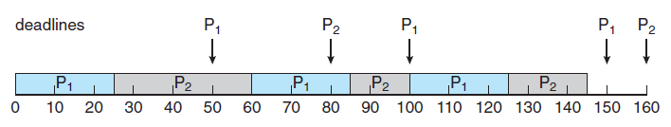

Process | Execution Time (C) | Period (T) | Deadline
P1 | 20 | 50 | 50
P2 | 35 | 80 | 80

Time | Ready Queue | Running
0 | P1(50), P2(80) | P1
20 | P2(80) | P2
50 | P2(80), P1(100) | P2 ⚡
55 | P1(100) | P1
75 | — | Idle

Time Interval | Running Process | P1 Deadline | P2 Deadline | Higher Priority | What Happens
0 – 20 | P1 | 50 | 80 | 🔥 P1 | P1 has earliest deadline → runs
20 – 50 | P2 | — | 80 | 🔥 P2 | P1 finished → P2 runs
50 (Event) | — | 100 (new) | 80 | 🔥 P2 ⚡ | Priority changes here (EDF)
50 – 55 | P2 | 100 | 80 | 🔥 P2 | P2 continues (no preemption)
55 – 75 | P1 | 100 | — | 🔥 P1 | P2 finished → P1 runs
75 – 80 | Idle | — | — | — | No process ready

Time | Ready Queue | Running
0 | P1(50), P2(80) | P1
20 | P2(80) | P2
50 | P2(80), P1(100) | P2 ⚡
55 | P1(100) | P1
75 | — | Idle

Time | Event | Ready Queue (Deadline) | Running Process | Why / Priority Decision
0 | Both arrive | P1(50), P2(80) | 🔥 P1 | 50 < 80 → P1 highest priority
0–20 | Execution | P2(80) | P1 | P1 runs and completes
20 | P1 done | P2(80) | 🔥 P2 | Only P2 available
20–50 | Execution | — | P2 | P2 continues running
50 | ⚡ P1 arrives | P2(80), P1(100) | 🔥 P2 | 80 < 100 → P2 still higher priority
50–55 | Execution | P1(100) | P2 | ✔ P2 continues (NO preemption)
55 | P2 completes | P1(100) | 🔥 P1 | Only P1 left
55–75 | Execution | — | P1 | P1 runs and completes
75 | All done | — | Idle | CPU idle

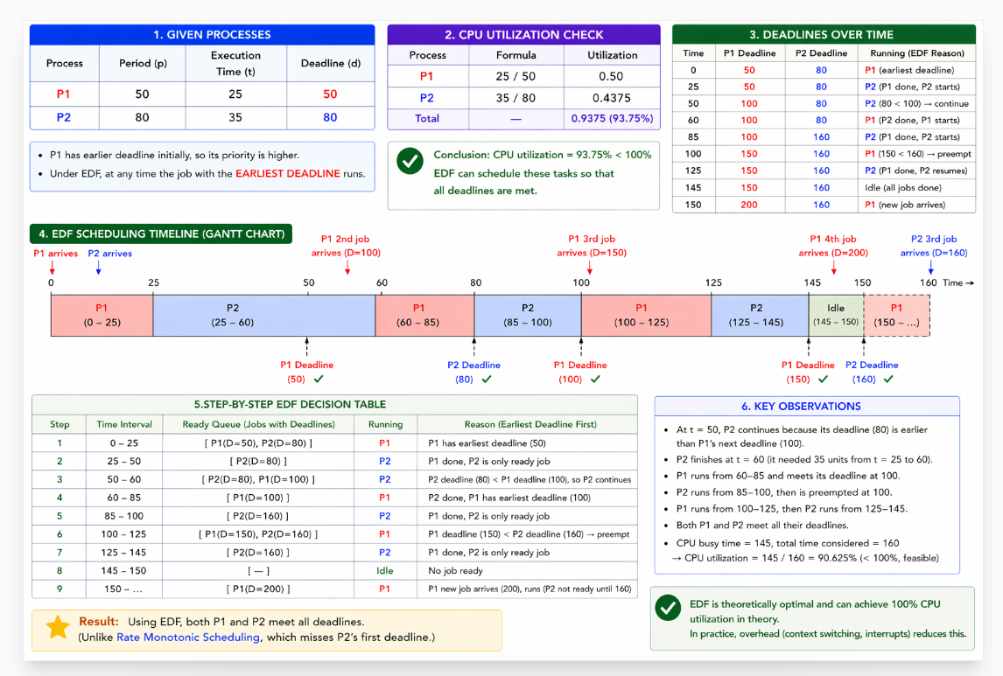

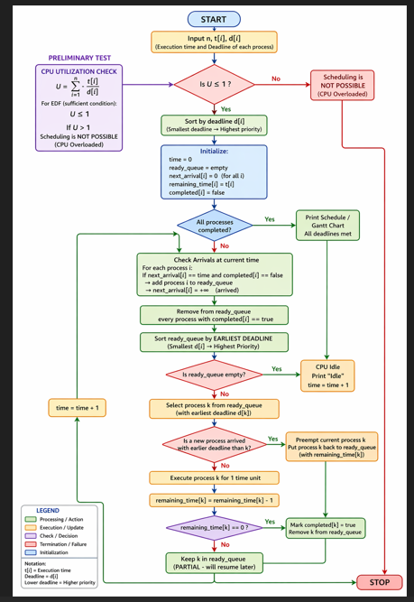

6.6.5 Proportional Share Scheduling
Proportional share schedulers operate by allocating T shares among all applications. An application can receive N shares of time, thus ensuring that the application will have N/T of the total processor time.
As an example, assume that a total of T = 100 shares is to be divided among three processes, A, B, and C. A is assigned 50 shares, B is assigned 15 shares, and C is assigned 20 shares. This scheme ensures that A will have 50 percent of total processor time, B will have 15 percent, and C will have 20 percent.
Proportional share schedulers must work in conjunction with an admission-control policy to guarantee that an application receives its allocated shares of time. An admission-control policy will admit a client requesting a particular number of shares only if sufficient shares are available

Process | Shares (S) | Calculation (S / T × 100) | CPU % | CPU Time (out of 20)
A | 50 | 50 / 100 × 100 | 50% | 10 units
B | 15 | 15 / 100 × 100 | 15% | 3 units
C | 20 | 20 / 100 × 100 | 20% | 4 units
Unused | 15 | 15 / 100 × 100 | 15% | 3 units

Total Shares | Total CPU Time | Used CPU Time | Unused CPU Time
100 | 20 units | 17 units | 3 units

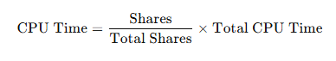

Time | A Used | B Used | C Used | Who Runs | Why
0 | 0 | 0 | 0 | A | Highest share (50%)
1 | 1 | 0 | 0 | B | B hasn’t run yet
2 | 1 | 1 | 0 | C | C hasn’t run yet
3 | 1 | 1 | 1 | A | A far below target (10)
4 | 2 | 1 | 1 | A | Still below target
5 | 3 | 1 | 1 | B | B needs progress (target 3)
6 | 3 | 2 | 1 | A | A still behind
7 | 4 | 2 | 1 | A | A still below
8 | 5 | 2 | 1 | C | C needs to reach 4
9 | 5 | 2 | 2 | A | A still below
10 | 6 | 2 | 2 | A | A progressing
11 | 7 | 2 | 2 | B | B needs final slot
12 | 7 | 3 | 2 | A | A continues
13 | 8 | 3 | 2 | C | C needs final slot
14 | 8 | 3 | 3 | A | A continues
15 | 9 | 3 | 3 | A | Near completion
16 | 10 | 3 | 3 | C | Final balance (C completes 4)

Schedulable Example under RMS

1. Example Task Set
Task | Execution Time (C) | Period (T) | Priority
P1 | 1 ms | 4 ms | High
P2 | 1 ms | 5 ms | Low
P1 has higher priority because it has smaller period.

2. LCM Calculation
Periods = 4 and 5
LCM(4,5) = 20 ms
Therefore, the scheduling pattern repeats after every 20 ms.

3. CPU Utilization Calculation
Utilization Formula:
U = C1/T1 + C2/T2
U = 1/4 + 1/5
U = 0.25 + 0.20 = 0.45
CPU Utilization = 45%

4. RMS Schedulability Check
Metric | Value
Calculated Utilization | 45%
RMS Limit (n=2) | 82.8%
Conclusion | Schedulable
Since 45% is less than 82.8%, the system is schedulable under RMS.

5. RMS Scheduling Table
Time Interval | Running Process | Reason | Status
0 – 1 | P1 | Higher priority | Meets deadline
1 – 2 | P2 | P1 completed | Meets deadline
2 – 4 | Idle | No task ready | -
4 – 5 | P1 | New instance arrives | Meets deadline
5 – 6 | P2 | Next P2 instance | Meets deadline
8 – 9 | P1 | Higher priority | Meets deadline

6. Gantt Chart
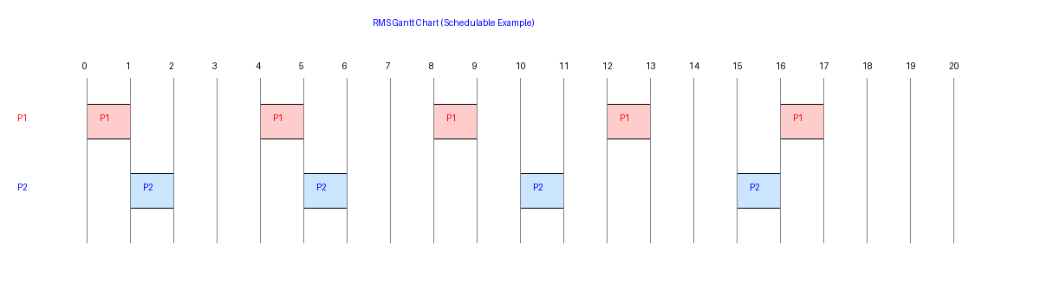

7. Summary
In this example, the CPU utilization is only 45%, which is below the RMS bound of 82.8%. Hence all tasks meet their deadlines and the system is schedulable.

Earliest Deadline First (EDF) Scheduling

1. What is EDF Scheduling?
Earliest Deadline First (EDF) is a dynamic priority real-time scheduling algorithm. The process having the earliest deadline gets the highest priority.
EDF can schedule tasks successfully as long as CPU utilization is less than or equal to 100%.

2. Example Task Set
Task | Execution Time (C) | Period/Deadline (T) | Priority Rule
P1 | 1 ms | 4 ms | Earlier deadline → Higher priority
P2 | 2 ms | 5 ms | Later deadline → Lower priority

3. CPU Utilization Calculation
Utilization Formula:
U = C1/T1 + C2/T2
U = 1/4 + 2/5
U = 0.25 + 0.40 = 0.65
CPU Utilization = 65%

4. EDF Schedulability Rule
EDF schedulability condition:
CPU Utilization ≤ 100%
Metric | Value
Calculated Utilization | 65%
EDF Limit | 100%
Conclusion | Schedulable
Since 65% is less than 100%, the task set is schedulable under EDF.

5. Hyperperiod using LCM
Periods = 4 and 5
LCM(4,5) = 20 ms
Therefore, the schedule repeats after every 20 ms.

6. EDF Scheduling Table
Time Interval | Running Process | Reason | Deadline Status
0 – 1 | P1 | Earlier deadline | Within deadline
1 – 3 | P2 | Next earliest deadline | Within deadline
4 – 5 | P1 | New earliest deadline | Within deadline
5 – 7 | P2 | Next EDF selection | Within deadline
8 – 9 | P1 | Earlier deadline | Within deadline

7. EDF Gantt Chart
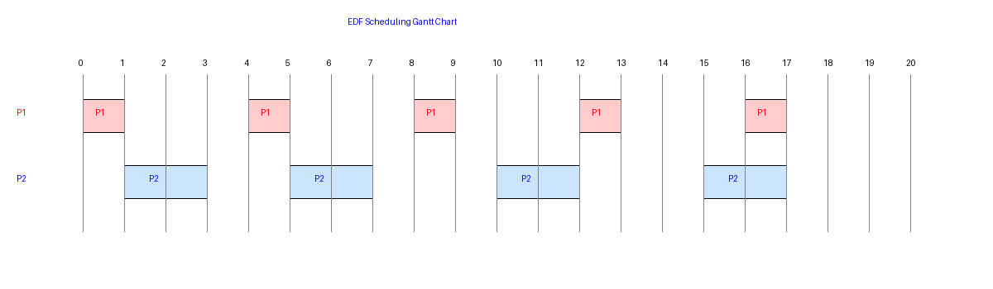

8. Summary
EDF scheduling dynamically assigns priority based on deadlines. A task set is schedulable if total CPU utilization is less than or equal to 100%. The LCM of task periods gives the hyperperiod after which the schedule repeats.

